**Exercise 1: Setting Up JUnit**

Scenario:

You need to set up JUnit in your Java project to start writing unit tests.

Steps:

1. Create a new Java project in your IDE (e.g., IntelliJ IDEA, Eclipse).

2. Add JUnit dependency to your project. If you are using Maven, add the following to your

pom.xml:

<dependency>

<groupId>junit</groupId>

<artifactId>junit</artifactId>

<version>4.13.2</version>

<scope>test</scope>

</dependency>

3. Create a new test class in your project.

CODE:

**Calculator.java**

package com.example;  
  
public class Calculator {  
 public int add(int a, int b) {  
 return a + b;  
 }  
}

**CalculatorTest.java**

package com.example;  
  
import org.junit.Test;  
import static org.junit.Assert.*assertEquals*;  
  
public class CalculatorTest {  
 @Test  
 public void testAdd() {  
 Calculator calc = new Calculator();  
 *assertEquals*(5, calc.add(2, 3));  
 }  
}

OUTPUT:

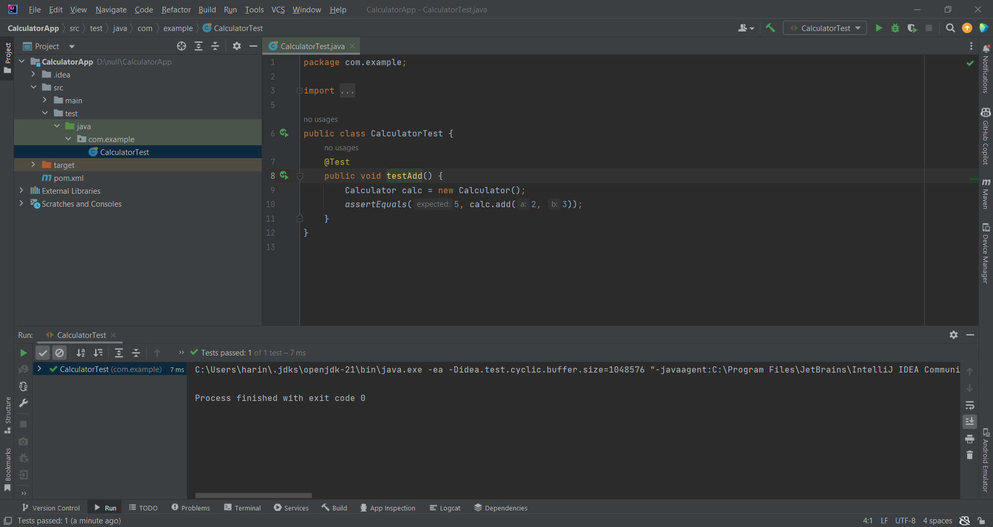

**Exercise 3: Assertions in Junit**

**Scenario:**

**You need to use different assertions in JUnit to validate your test results.**

**Steps:**

**1. Write tests using various JUnit assertions.**

**CODE:**

public class AssertionsTest {

@Test

public void testAssertions() {

// Assert equals

assertEquals(5, 2 + 3);

// Assert true

assertTrue(5 > 3);

// Assert false

assertFalse(5 < 3);

// Assert null

assertNull(null);

// Assert not null

assertNotNull(new Object());

}

}

**OUTPUT :**

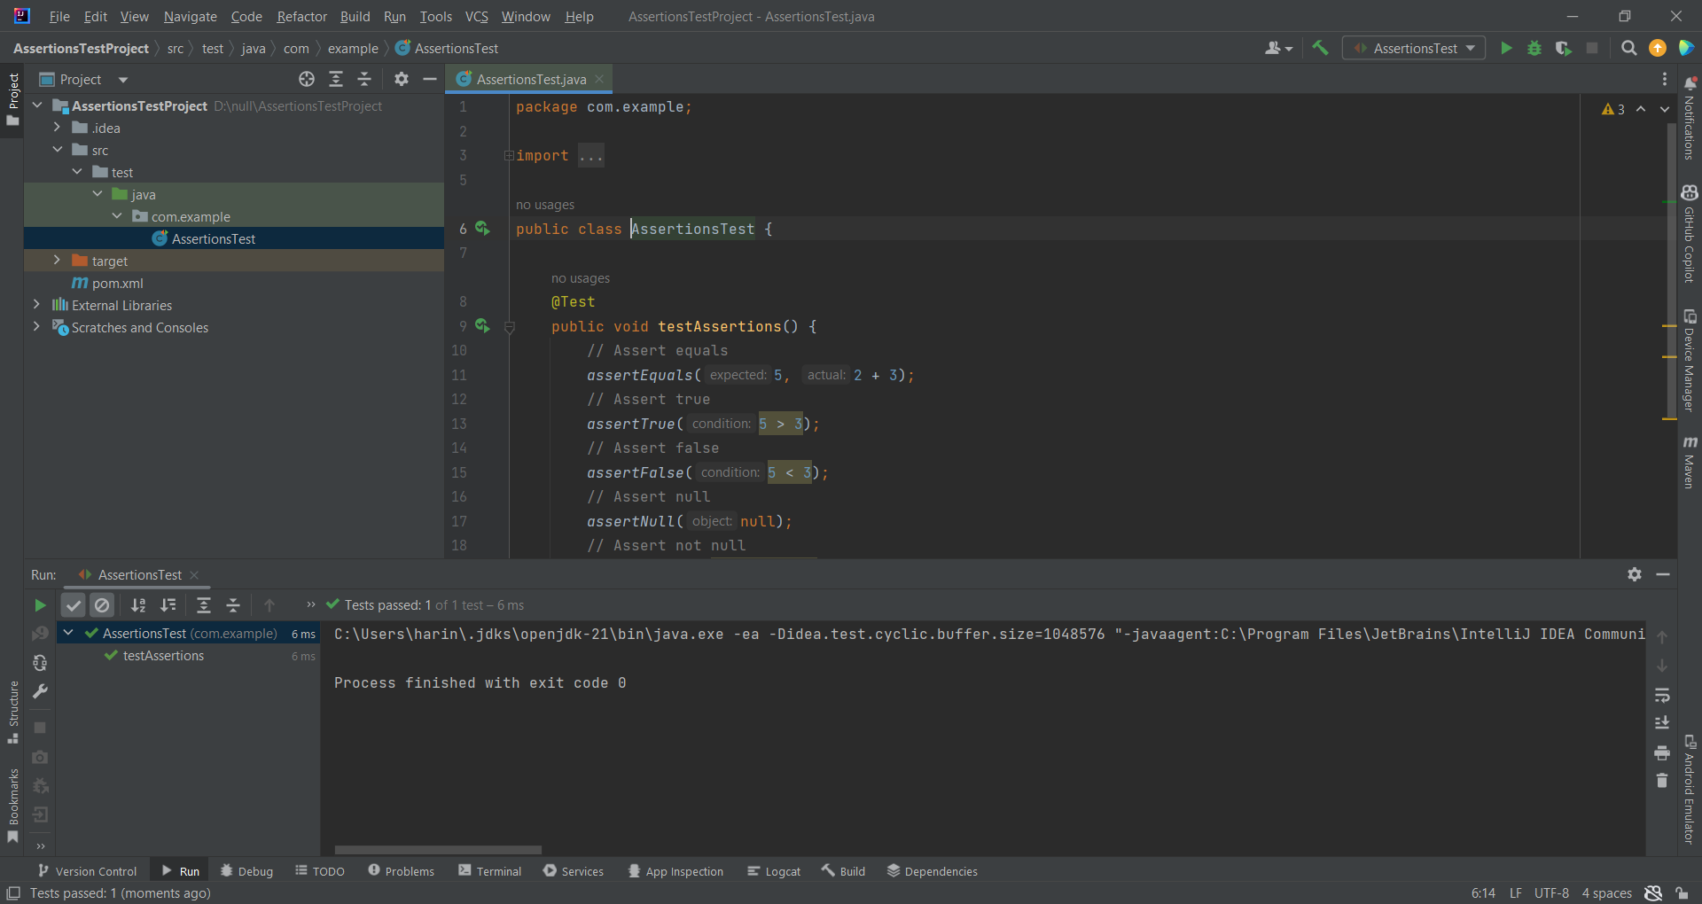

**Exercise 4: Arrange-Act-Assert (AAA) Pattern, Test Fixtures, Setup and**

**Teardown Methods in JUnit**

**Scenario:**

**You need to organize your tests using the Arrange-Act-Assert (AAA) pattern and use setup**

**and teardown methods.**

**Steps:**

**1. Write tests using the AAA pattern.**

**2. Use @Before and @After annotations for setup and teardown methods.**

**CODE:**

package com.example;  
  
import org.junit.After;  
import org.junit.Before;  
import org.junit.Test;  
import static org.junit.Assert.*;  
  
public class CalculatorTest {  
  
 private Calculator calculator;  
  
 @Before  
 public void setUp() {  
 System.*out*.println("Setting up...");  
 calculator = new Calculator();  
 }  
  
 @After  
 public void tearDown() {  
 System.*out*.println("Tearing down...");  
 calculator = null;  
 }  
  
 @Test  
 public void testAdd() {   
 int a = 2;  
 int b = 3;  
  
 int result = calculator.add(a, b);  
  
 *assertEquals*(5, result);  
 }  
  
 private static class Calculator {  
 public int add(int a, int b) {  
 return a + b;  
 }  
 }  
}

**OUTPUT:**

